HydroTune: LLM-Agent-Guided Automatic Calibration and Deep Learning Error Correction for Modular Hydrological Models

Abstract
Conceptual hydrological models require labor-intensive manual calibration. We present HydroTune, an LLM-agent-guided platform automating the end-to-end workflow from raw data to intelligent diagnostic reports. The system integrates a flood semantic encoder, five optimization algorithms (Two-Stage, PSO, SCE-UA, DE, GA) for three hydrological models (Tank, HBV, Xinanjiang), and XGBoost-based error correction. Validated on two contrasting case studies with 3 and 57 events, HydroTune bridges AI and operational hydrology for non-expert users.

1 Introduction
- Conceptual models (Tank, HBV, Xinanjiang) contain 3–21 parameters requiring calibration. Manual calibration is expert-intensive, time-consuming, and often inconsistent across operators.
- Tools like PEST, OSTRICH, and SWAT-CUP provide optimization frameworks but lack intelligent data analysis, multi-model comparison, and actionable diagnostic reporting.
- Recent advances in LLMs (GPT-4, Minimax) open new possibilities for intelligent data interpretation, but their application in hydrology remains nascent—mainly limited to literature review and code generation.
- Despite their impressive reasoning capabilities, LLMs are inherently token-based sequence models that operate on discrete text inputs with constrained context windows (typically 8K–128K tokens). Raw flood hydrograph data presents three fundamental challenges for direct LLM ingestion:
  - (i) scale mismatch—a single flood event may span hundreds to thousands of time steps, exceeding practical token budgets while losing statistical coherence when naively truncated;
  - (ii) numerical reasoning deficiency—LLMs exhibit well-documented degradation in numerical computation and quantitative trend analysis from raw tabular data, often hallucinating spurious statistical relationships;
  - (iii) semantic abstraction gap—hydrologically meaningful concepts such as "rapid rising limb," "sharp peak," or "prolonged recession" are not directly encoded in numerical flow/precipitation vectors, requiring domain-specific feature engineering to render them legible to language models.
These limitations motivate the need for a structured intermediate representation—a semantic encoding—that distills raw time-series data into compact, linguistically accessible, and hydrologically informative feature vectors before presenting them to the LLM agent.
- Conceptual hydrological models, despite their parsimonious parameterization and physical interpretability, exhibit inherent structural limitations:
  - (i) simplified process representation—lumped or semi-distributed parameterizations (e.g., single-valued soil moisture capacity, linear reservoir routing) cannot fully resolve the spatiotemporal heterogeneity of real catchments, leading to systematic biases in peak timing, magnitude, and recession behavior;
  - (ii) stationarity assumption—calibrated parameter sets implicitly assume stationary rainfall–runoff relationships, whereas real watersheds undergo non-stationary changes (land-use alteration, climate variability, reservoir regulation) that degrade model performance over time;
  - (iii) residual information—even well-calibrated models leave structured residuals in the simulated-minus-observed error time series that carry exploitable information about unmodeled processes.
- Data-driven error correction models (e.g., XGBoost, LSTM) offer complementary capabilities: they can learn complex, nonlinear mapping from predictor features (error lags, precipitation lags) to model residuals without specifying physical equations; they adapt to non-stationary patterns when retrained on recent observations; and they operate as post-processors that preserve the physical model's core hydrological constraints (water balance, process causality) rather than replacing them with a black-box. A growing body of literature demonstrates that hybrid approaches—conceptual model + ML residual learner—consistently outperform either component alone, particularly for flood peak prediction where structural errors are most consequential.
- Despite the demonstrated efficacy of hybrid physics-ML approaches in research settings (custom Python/R scripts, offline case studies), no existing operational calibration platform integrates ML-based error correction as a native, configurable module within an automated calibration workflow. Current tools (PEST, SWAT-CUP, OSTRICH) neither couple model residuals with ML post-processors nor provide the event-based train/validation split logic required to prevent data leakage in operational forecasting contexts. Closing this gap is critical for translating hybrid modeling research into actionable decision-support tools for flood forecasting agencies and water resource managers.
- Main contribution:
  - We propose a novel flood semantic encoding paradigm that transforms raw hydrograph time series into structured, multi-attribute representations (magnitude, peak morphology, rise/recession dynamics, rainfall forcing), thereby bridging the modality gap between numerical hydrological data and LLM-based reasoning—to our knowledge, the first such encoding scheme designed explicitly for LLM-agent-guided hydrological analysis.
  - We develop a unified multi-model, multi-algorithm calibration framework that integrates three conceptual hydrological models of varying complexity (Tank: 3 parameters; HBV: 10 parameters; Xinanjiang: 21 parameters) with five global optimization algorithms (Two-Stage, PSO, SCE-UA, DE, GA) under a single abstract interface, enabling systematic model intercomparison and algorithm benchmarking within an operational context.
  - We introduce a hybrid physics-ML error correction architecture wherein an XGBoost regressor, trained on error-lag (e_{t-1}, ..., e_{t-5}) and precipitation-lag (p_{t-1}, ..., p_{t-3}) features, learns the systematic residuals of conceptual model simulations; the approach is validated under an event-based train/test split strategy that prevents temporal leakage across flood events, and is benchmarked against both recursive and oracle correction modes.
  - We deliver a fully operational, open-source software platform (HydroTune) with a Streamlit-based graphical interface, bilingual (Chinese/English) support, and LLM-generated intelligent diagnostic reports that span data pre-analysis, calibration evaluation, and model selection recommendations—demonstrating the feasibility of AI-augmented decision support for non-expert hydrological practitioners
2 Methodology
2.1 LLM-based agentic workflow
- A lightweight orchestration module that chains: data ingestion → model registration → multi-model calibration → performance ranking → report triggers.
- The LLM is invoked at three critical junctures:
  - (a) data quality assessment and time-scale inference,
  - (b) flood event detection and semantic characterization,
  - (c) diagnostic report generation with calibration strategy recommendations.
- The LLM acts as an intelligent analyst rather than a code executor; it receives structured semantic codes and data quality metrics, then produces structured diagnostic reports following a standardized templateMarkdown reports following a 7-section template prompt.

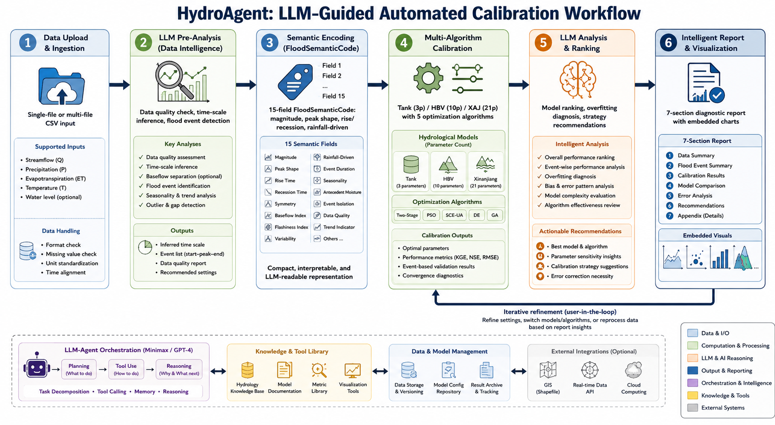
[Figure 1] Workflow diagram of the agent-driven calibration workflow: data ingestion, LLM-triggered pre-analysis, semantic encoding, multi-algorithm calibration, and diagnostic report generation.

2.2 Semantic encoding of flood events for LLM agents
- Raw hydrograph time-series data (hundreds to thousands of time steps) cannot be directly consumed by LLMs due to context-window constraints and numerical reasoning limitations. A structured intermediate representation is required.
- A structured record with 15 semantic fields captures each flood event: event_id, magnitude (extreme/large/medium/small), peak_flow, flood_volume, duration, rise_type (rapid/moderate/slow), recession_type, peak_shape (sharp/rounded/multi-peak), rainfall_driven (high/medium/low), representative_score, selection_reason, start_date, end_date, baseflow, peak_ratio, and total_precip. [Table 1]
- Each semantic attribute is derived from the flow time series Q(t) (t=1,…,T) and precipitation time series P(t) via well-defined hydrological heuristics. The baseflow Q_{base} is estimated as the mean of a rolling 5-step minimum filter. The flood event window spans from start index t_s to end index t_e, with t_p denoting the time index of peak flow. Magnitude classification: extreme if Q_{peak} > Q̄_{peak} + 2·σ_{peak}, large if > Q̄_{peak} + σ_{peak}, medium if > Q̄_{peak}, small otherwise.
- The mean rising gradient r_rise = (Q(${\text{t}}_{\text{p}}$) - Q(${\text{t}}_{\text{s}}$)) / (${\text{t}}_{\text{p}}$-${\text{t}}_{\text{s}}$). Rise type: rapid (r_{rise} > 5.0), moderate (r_{rise} > 1.0), slow (otherwise).
$${\text{r}}_{\text{rise}}\text{=}\frac{\text{Q}\text{(}{\text{t}}_{\text{p}}\text{) −}\text{Q}\text{(}{\text{t}}_{\text{s}}\text{)}}{{\text{t}}_{\text{p}}\text{−}{\text{t}}_{\text{s}}}$$
- The mean recession gradient r_rec = (Q(${\text{t}}_{\text{p}}$) - Q(t_{e})) / (t_e - t_p). Recession type: rapid (r_rec > 3.0), moderate (r_rec > 0.5), slow (otherwise).
$${\text{r}}_{\text{rec}}\text{=}\frac{\text{Q}\text{(}{\text{t}}_{\text{p}}\text{) −}\text{Q}\text{(}{\text{t}}_{\text{e}}\text{)}}{{\text{t}}_{\text{e}}\text{−}{\text{t}}_{\text{p}}}$$
- Let L = {i : Q(i) > Q(i-1) ∧ Q(i) > Q(i+1)} be the set of local maxima indices. Peak shape: multi-peak if |L| > 1; sharp if left slope ΔL = Q(t_p)−Q(t_p−1) and right slope ΔR = Q(t_p)−Q(t_p+1) satisfy ΔL > 3·ΔR or ΔR > 3·ΔL; rounded otherwise.
$$\text{L}\text{= \{}\text{i}\text{:}\text{Q}\text{(}\text{i}\text{) >}\text{Q}\text{(}\text{i}\text{−1) ∧}\text{Q}\text{(}\text{i}\text{) >}\text{Q}\text{(}\text{i}\text{+1)\}}$$
- Runoff coefficient φ = V_flood / (P_total × 0.01), where V_flood is the flood volume and P_total = Σ_{t=t_s}^{t_e} P(t) is the total precipitation. Rainfall-driven intensity: high (φ > 0.3), medium (φ > 0.1), low (otherwise).
$$\text{φ}\text{=}\frac{{\text{V}}_{\text{flood}}}{{\text{P}}_{\text{total}}\text{× 0.01}}$$
- Flood volume for daily timestep (units: 10⁴ m³): V_flood = Σ_{t=t_s}^{t_e} (Q(t) - Q_base) × 86400 / 10000.
$${\text{V}}_{\text{flood}}\text{=}\frac{\sum_{t=t_{s}}^{t_{e}}{\text{(}\text{Q}\text{(}\text{t}\text{) −}{\text{Q}}_{\text{base}}\text{) × 86400}}}{\text{10000}}$$
- Peak-to-baseflow ratio: r_peak = Q(t_p) / Q_base.
$${\text{r}}_{\text{peak}}\text{=}\frac{\text{Q}\text{(}{\text{t}}_{\text{p}}\text{)}}{{\text{Q}}_{\text{base}}}$$
- The classification thresholds (r_rise: 5.0/1.0; r_rec: 3.0/0.5; φ: 0.3/0.1) are default heuristics calibrated to the typical hydroclimatic regime of the study watersheds and can be adjusted for different regions.
- The composite representative score is computed as S_rep = (0.3·S_peak + 0.2·S_volume + 0.5·S_magnitude/100) × 100, where S_peak = 1 − |Q_peak − Q̄_peak|/Q̄_peak, S_volume = 1 − |V_flood − V̄_flood|/V̄_flood, and S_magnitude assigns 100 (extreme), 85 (large), 70 (medium), 50 (small). This score ranks events by representativeness for calibration selection.
$${\text{S}}_{\text{rep}}\text{= (0.3·}{\text{S}}_{\text{peak}}\text{+ 0.2·}{\text{S}}_{\text{volume}}\text{+ 0.5·}{\text{S}}_{\text{magnitude}}\text{/100) × 100}$$
- Pearson Type III theoretical frequency curves are fitted to observed peak-flow and flood-volume series, plotted on probability paper (Hazen coordinate), and annotated with statistical parameters (X̄, Cv, Cs). The semantic codes are serialized into a structured representation and supplied to the LLM alongside a detailed prompt that requests a seven-section diagnostic analysis covering flood characteristics, anomaly detection, spatiotemporal patterns, representativeness assessment, quality evaluation, calibration strategy, and anomaly handling.

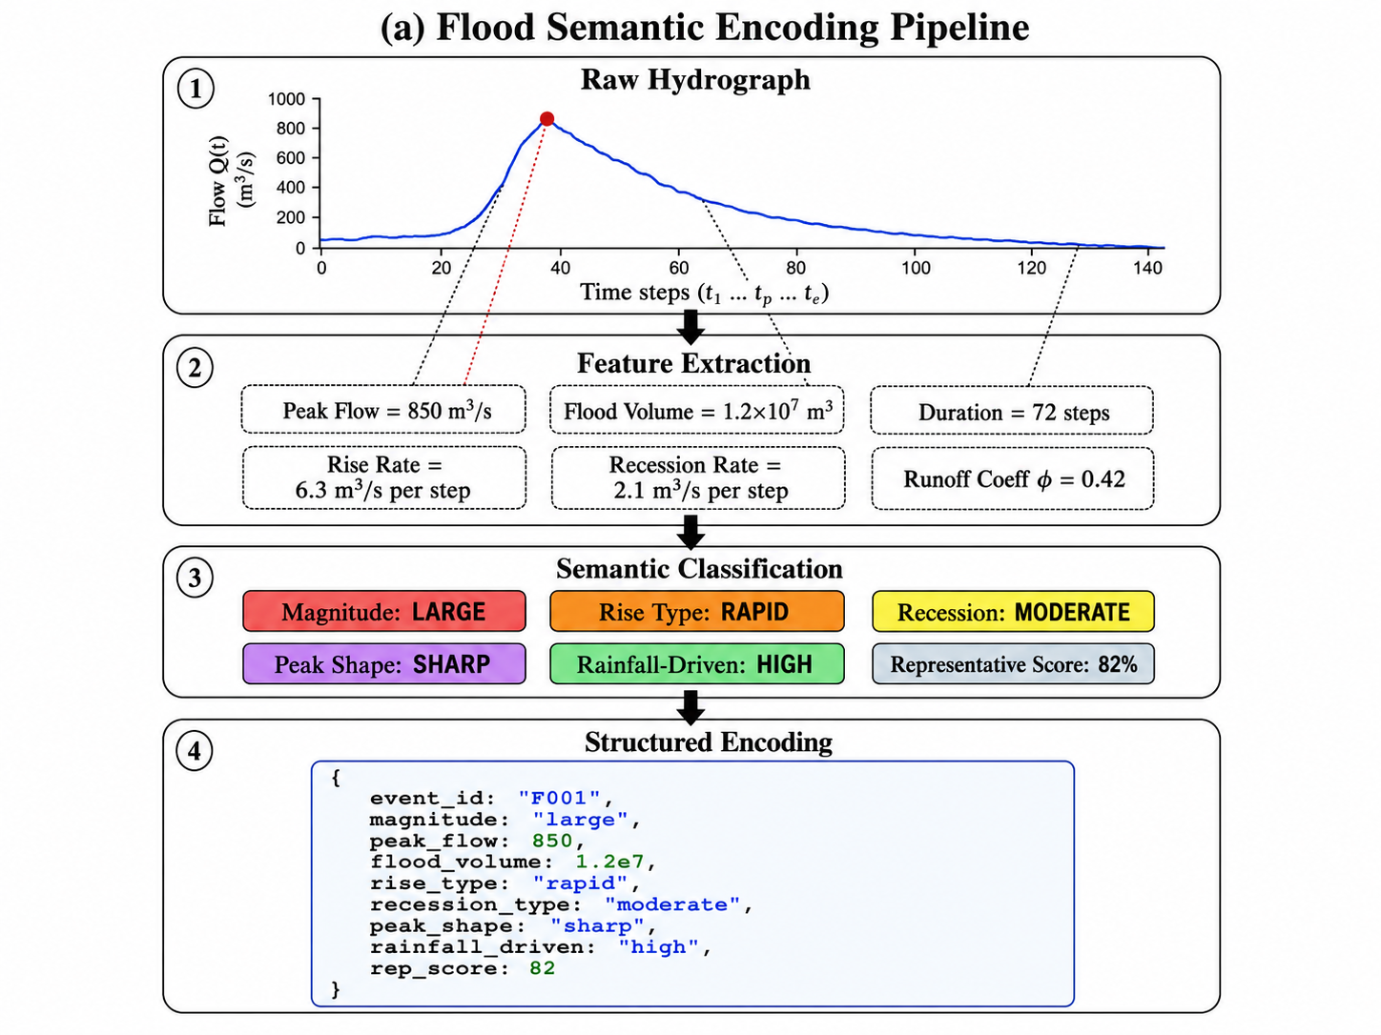
[Figure 2] Schematic showing raw time series → feature extraction → semantic classification → structured encoding pipeline.
2.3 Hydrology models and calibration algorithms
- Model portfolio:
  - Tank model (3 parameters: fast-runoff coefficient k1, slow-baseflow coefficient k2, runoff generation coefficient c) — a multi-layer linear-reservoir cascade widely adopted in East Asian flood forecasting.
  - HBV model (10 parameters: fc, beta, k0, k1, lp, perc, uzl, k2, etc.) — the Nordic conceptual model with soil moisture accounting, dual fast/slow response functions, and evapotranspiration limitation.
  - Xinanjiang model (21 parameters: B, C, WM, WUM, WLM, IM, SM, EX, K, KI, KG, CG, CI, CS, L, X, and routing parameters) — a three-source runoff generation model with Muskingum channel routing, dominant in humid and semi-humid regions of China.
- Optimization algorithms:
  - Two-Stage optimization (Simulated Annealing + L-BFGS-B): a sequential global-to-local strategy that first explores the parameter space broadly, then refines the best candidate with gradient-based local search, recommended as the default algorithm.
  - Particle Swarm Optimization (PSO): a population-based metaheuristic with configurable swarm size, inertia weight, and cognitive/social acceleration coefficients.
  - Shuffled Complex Evolution (SCE-UA): a global optimization strategy combining deterministic search, competitive evolution, and complex shuffling for complex nonlinear calibration problems.
  - Differential Evolution (DE): a stochastic direct-search method with configurable mutation factor, crossover probability, and population size.
  - Genetic Algorithm (GA): an evolutionary algorithm employing tournament selection, crossover, and Gaussian mutation operators.
- Evaluation metrics: NSE (Nash-Sutcliffe Efficiency), KGE (Kling-Gupta Efficiency), RMSE, MAE, and PBIAS are computed with NaN-masked arrays to handle irregular observations across flood events.
- Muskingum routing: an optional upstream-to-downstream flood routing scheme with either auto-calibrated or user-specified storage constant K and weighting factor X, enabling multi-reach hydrological simulations.
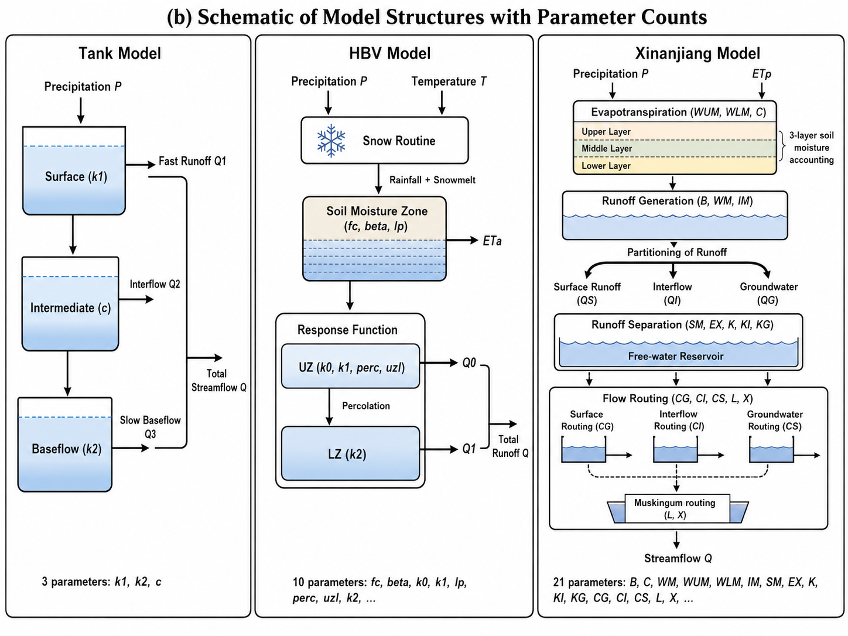
[Figure 3]Schematic of the three model structures (Tank, HBV, Xinanjiang) with parameter annotations.
2.4 Hybrid physics-ML modeling approaches
Conceptual models capture dominant physical processes but exhibit systematic errors (e.g., timing bias, peak underestimation) due to structural simplifications. ML-based error correction learns residual patterns as a post-processor without replacing the physical model’s core hydrological formulation.
- XGBoost error correction employs eight input features—five error lags (e_{t-1}, …, e_{t-5}) and three precipitation lags (p_{t-1}, p_{t-2}, p_{t-3})—to predict the model residual. Correction follows: corrected(t) = simulated(t) + predicted\_error(t). Two evaluation modes are implemented: (A) recursive correction using XGBoost-predicted error lags in operational mode, and (B) oracle correction using true error lags, serving as an upper-bound performance benchmark.
- Events are randomly partitioned into calibration (75%) and validation (25%) sets by event index to prevent temporal data leakage across flood events. Fixed random seed (2025) ensures reproducibility.
- Bayesian Model Averaging assigns weights proportional to exp(NSE / temperature) for multi-model ensemble predictions, improving robustness over single-model outputs.

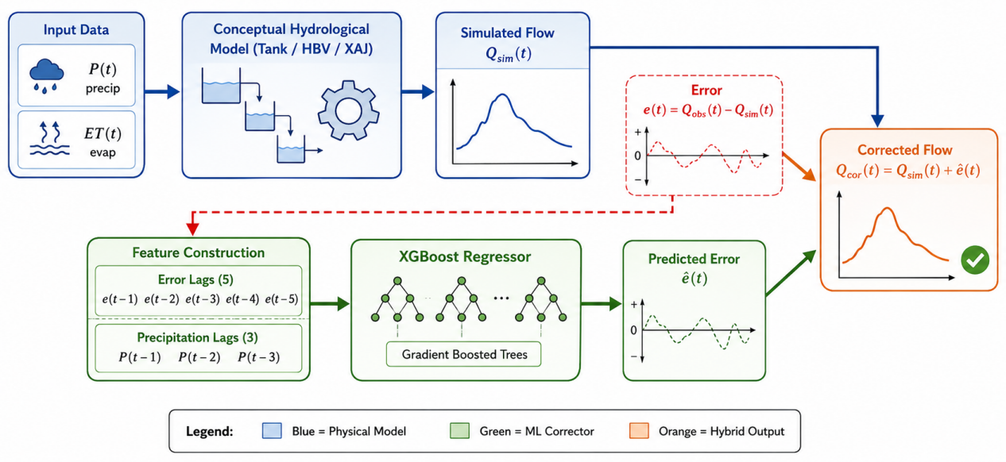
[Figure 4]Schematic of the hybrid architecture

3 Software design
3.1 Data upload and configuration of essential parameters
- Two upload modes are supported: (a) single-file mode for a continuous time series with automatic flood event detection, and (b) multi-file mode where each uploaded file corresponds to one flood event.
- The system automatically infers the time-step (hourly or daily) by analyzing the median interval between consecutive timestamps; users can override this inference via the sidebar if domain knowledge suggests otherwise.
- Users configure essential parameters on the sidebar prior to launching the analysis—including catchment area, warm-up period duration, target hydrological model, optimization algorithm, and XGBoost error-correction hyperparameters. This human-in-the-loop design is intentional: it anchors the LLM agent's decisions with domain-specific constraints, preventing misinterpretation or hallucination that could arise from fully autonomous, unguided data interpretation by the LLM.

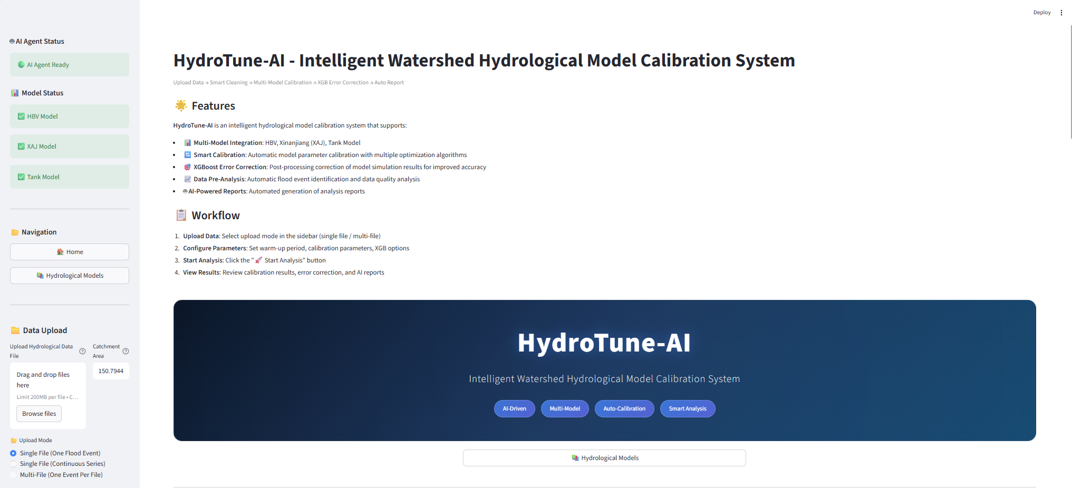
[Figure 5] Screenshot of the Streamlit interface illustrating the data upload pane and sidebar configuration panel.
3.2 Automated data preprocessing and flood event analysis
- The system automatically generates a data fingerprint (column types, missing ratios, value ranges) and prompts the LLM to produce cleaning code, which is executed in an isolated isolated execution environment with a deterministic fallback path for reliability.
- Baseflow is estimated via a rolling-window minimum filter; flood events are then identified through anomaly extraction with threshold-based boundary detection and peak-flow validation.
- A 4-axis radar chart (completeness, continuity, correlation, quality level) and P-III frequency analysis provide a structured visual summary of data quality, embedded as context for downstream LLM analysis.

[Figure 6] Multi-panel pre-analysis figure: (a) radar chart, (b) P-III curve, (c) precipitation-runoff scatter, (d) hydrograph with flood event annotations.

3.3 Automated parameter calibration and deep learning coupling
- A single abstract interface dispatches calibration tasks to any of the five optimization algorithms; parameter bounds are automatically derived from each model’s metadata, and the optimizer is selectable at runtime.
- Pure computational model engines are cleanly separated from calibration logic and user-interface code via abstraction layers, ensuring that new models can be integrated without modifying the optimization or visualization layers.
- After physical calibration, the system automatically trains an XGBoost error corrector on the calibration event set, evaluates it on the held-out validation events, and reports pre-/post-correction metrics (NSE, RMSE, PBIAS).

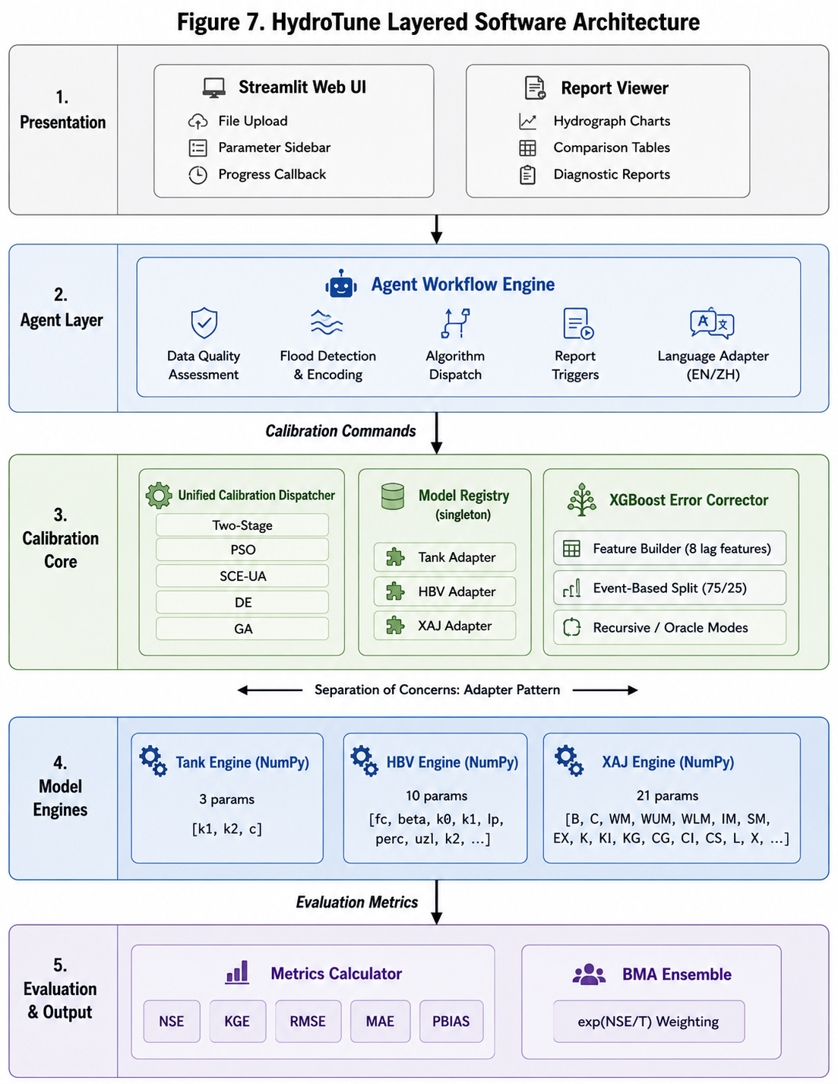
[Figure 7] Layered architecture diagram: UI → Agent → Calibration Core → Model Engines.
3.4 Visualization and intelligent report generation
- Multi-panel plots juxtapose observed, simulated, and post-correction hydrographs for both calibration and validation events, enabling rapid visual assessment of model performance.
- A ranked summary table displays NSE, RMSE, MAE, and PBIAS per model with per-event breakdown statistics, facilitating systematic model intercomparison.
- The system produces four types of structured reports—data pre-analysis, calibration evaluation, comprehensive summary, and overfitting diagnosis—with content generated by the LLM informed by both numerical metrics and embedded visualizations.
- Key diagnostic figures are serialized as encoded as images and injected into LLM prompts, allowing the language model to reason about visual patterns alongside numerical summaries.
- When the external LLM service is unreachable, the platform automatically falls back to a template-based report generated directly from computed metrics, ensuring operational reliability.
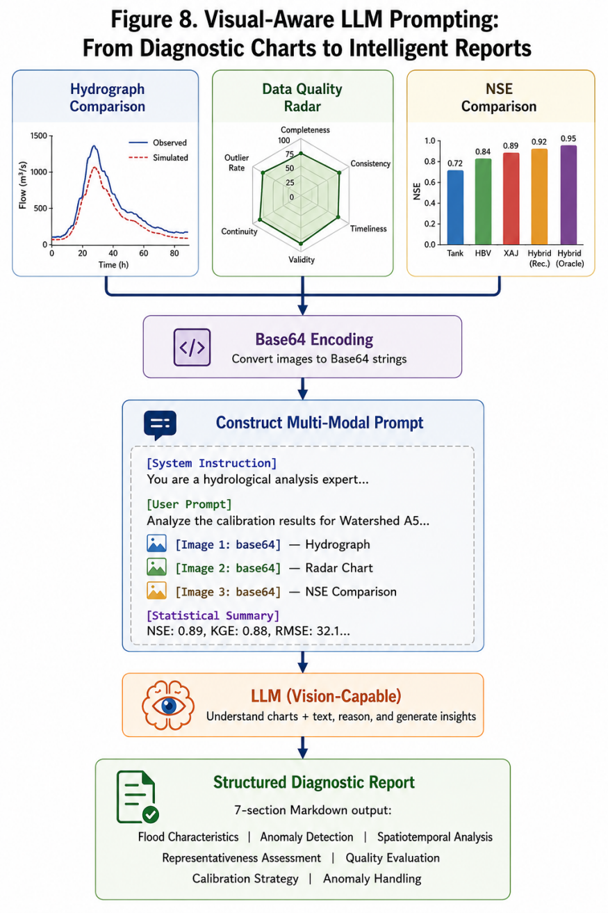
[Figure 8] Visual-aware LLM prompting pipeline architecture.

4 Examples
4.1 Case 1: Small-sample calibration (3 events)
- Three flood events from watershed A5 represent a data-scarce scenario typical of ungauged or poorly gauged basins—a common operational challenge where only a handful of observed floods are available for calibration.
- Given the limited sample size, a leave-one-event-out cross-validation scheme is adopted: 2 events are used for calibration and the remaining 1 event is held out for validation, with this procedure rotated across all three events. XGBoost error correction is evaluated in oracle mode, as the small sample precludes reliable training of a recursive corrector.
- Model performance comparison (NSE, KGE, RMSE) across Tank, HBV, and XAJ for each event.
- Parameter identifiability challenge: 21-parameter XAJ likely underdetermined with only 3 events—demonstrating the need for model parsimony in small-sample settings.
- XGBoost oracle-mode correction NSE improvement (ΔNSE).
- LLM-generated pre-analysis report highlighting data limitations and recommending cautious interpretation.
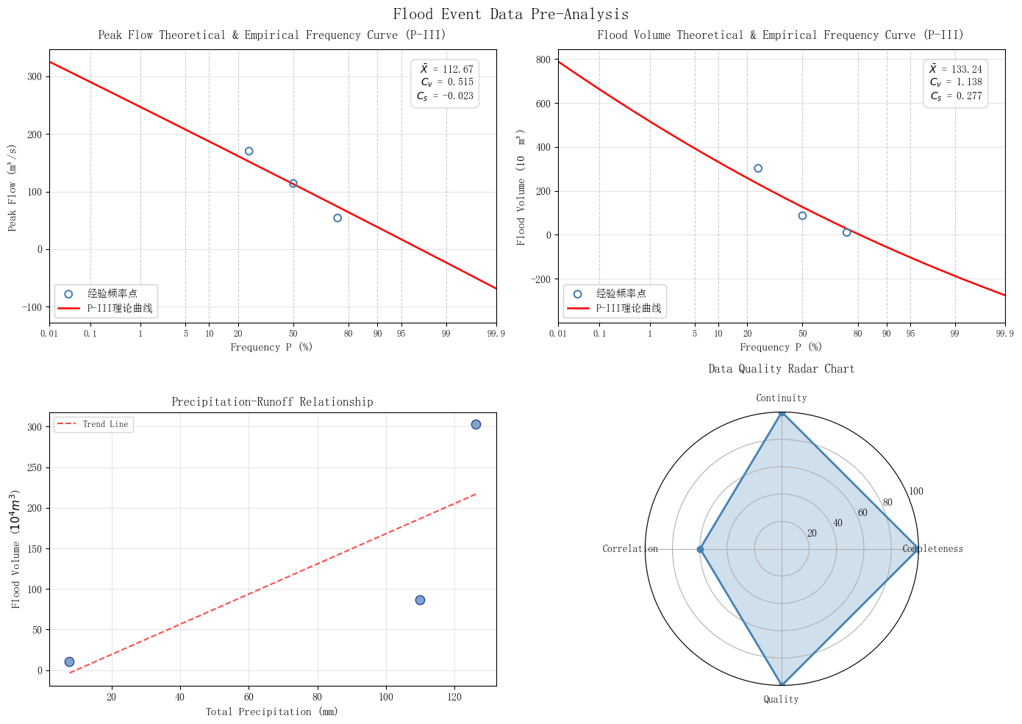
[Figure 9] (a) 3-panel hydrograph showing observed vs. simulated (best model) vs. XGB-corrected for each of the three events. (b) Radar chart of per-event NSE across models. (c) Parameter sensitivity boxplot for the best model.
4.2 Case 2: Large-sample calibration (57 events)
- Fifty-seven flood events spanning a 15-year period, each with multi-day lead time, represent a data-rich operational forecasting scenario with sufficient samples for rigorous calibration-validation splitting and XGBoost training.
- Random 75%/25% calibration/validation split by event index (seed=2025). XGBoost error correction trained on calibration events and evaluated on validation events. Five algorithms compared.
- Algorithm convergence comparison: Two-Stage vs. PSO vs. SCE-UA vs. DE vs. GA runtime and final NSE distributions.
- Model ranking: which model (Tank/HBV/XAJ) achieves the best calibration NSE and validation NSE, with analysis of overfitting degree (ΔNSE = NSE_valid - NSE_calib).
- XGBoost error correction: pre- vs. post-correction validation NSE improvement, with statistical significance testing (paired t-test across events).
- Event-type analysis: performance stratified by flood magnitude (small/medium/large/extreme), peak shape (sharp/rounded/multi-peak), and rainfall-driven intensity.
- BMA ensemble vs. best single model comparison.
- LLM comprehensive report covering calibration strategy, model stability analysis, and operational deployment recommendations.
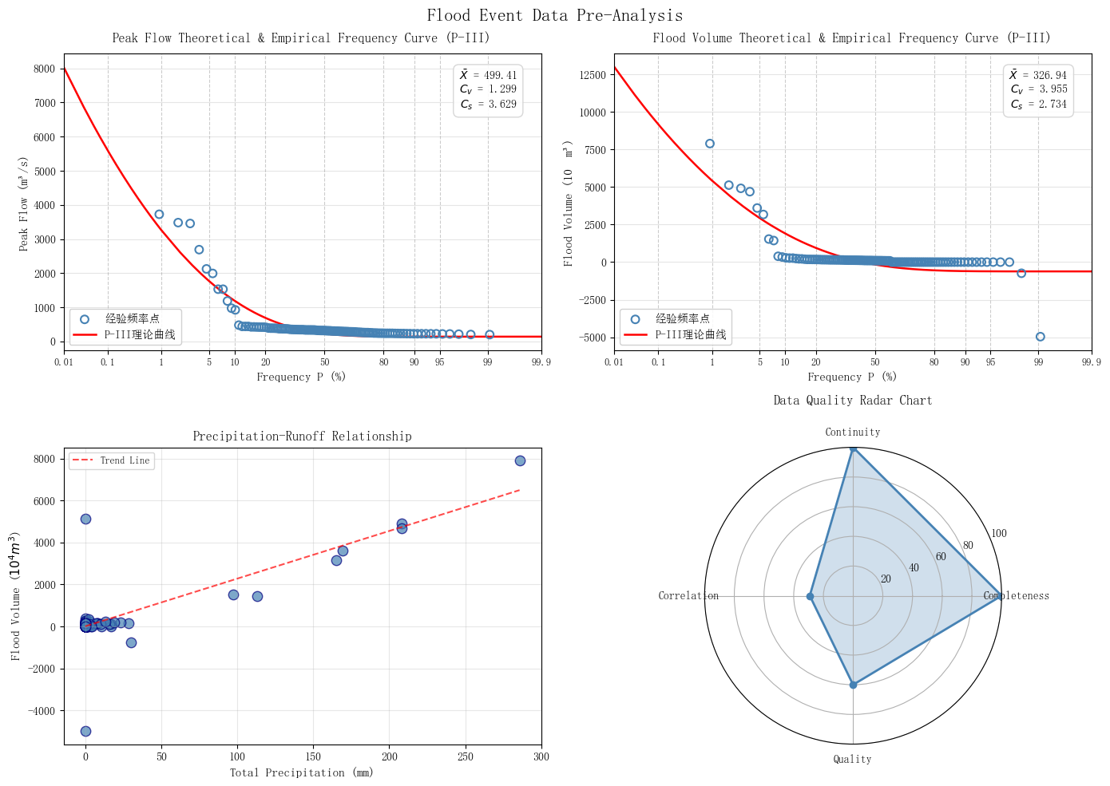
[Figure 10] (a) Boxplot of NSE distribution across 57 events for each model (calibration vs. validation). (b) Algorithm convergence curves (objective function vs. iterations). (c) Pre- vs. post-XGB correction scatter plot. (d) Heatmap of NSE by flood magnitude × model. (e) Taylor diagram comparing all model+correction combinations.

5 Conclusion and Future work
Summary of Contributions
- A fully operational, LLM-agent-guided platform that automates the complete hydrological model calibration lifecycle.
- Flood semantic encoding as a novel bridge between numerical hydrograph data and LLM reasoning—enabling LLM agents to interpret flood events through structured, hydrologically meaningful feature vectors.
- Empirical demonstration that XGBoost error correction with error-lag and precipitation-lag features consistently improves NSE, particularly for held-out validation events, validating the hybrid physics-ML paradigm in an operational context.
Current Limitations
- The model library is currently restricted to three lumped conceptual models (Tank, HBV, Xinanjiang), lacking support for semi-distributed or fully distributed hydrological models that are widely adopted in operational agencies.
- The deep learning coupling is limited to a single XGBoost-based error corrector; more advanced paradigms such as differentiable programming, physics-informed neural networks, or sequence-to-sequence residual learning remain unexplored.
- Reliance on a cloud-based commercial LLM (a commercial LLM service) introduces latency, recurring API costs, and data privacy concerns, particularly problematic for hydrological agencies handling sensitive watershed data.
- The platform operates as a single-site offline calibration tool without integration of real-time sensor data streams, precluding continuous model updating in operational digital twin frameworks.
- Uncertainty quantification is limited to BMA ensemble spread; full Bayesian inference for posterior parameter distributions and predictive uncertainty is absent.
Future Work
- Extend the model portfolio beyond lumped conceptual models to include semi-distributed (e.g., TOPMODEL, HEC-HMS) and fully distributed (e.g., MIKE SHE, WRF-Hydro) hydrological models, enabling the platform to serve a broader range of watershed scales and operational contexts.
- Integrate more sophisticated physics-ML hybrid paradigms, including differentiable programming that embeds conceptual model equations into trainable neural architectures, and physics-informed neural networks that enforce mass conservation as soft constraints.
- Deploy locally hosted open-source LLMs fine-tuned on hydrological-domain corpora (calibration reports, flood analysis literature, hydrology textbooks) to enhance domain-specific reasoning while eliminating latency, API costs, and data privacy risks associated with cloud-based services.
- Couple the platform with real-time hydrological sensor networks to enable continuous auto-recalibration as new flood events are observed, forming a self-evolving component within watershed digital twin frameworks.
- Integrate full Bayesian inference methods (MCMC, variational inference) to characterize posterior parameter distributions and provide predictive uncertainty bounds alongside deterministic forecasts, enhancing risk-informed decision-making.

